# keyestudio Sensor Shield V2 for Raspberry Pico

**1.Description**

keyestudio Sensor Shield V2 for Raspberry Pico is an expansion board dedicated to developing Raspberry Pi Pico, which doesn’t need to weld and the pins are fully led out. For easy connection, 2.54 anti-reverse plug terminals are used, and the ports on the expansion board are silkscreened.

The silkscreen of the 3pin port is generally G V S, and G on the expansion board represents GND, V implies VCC (3.3V/5V, note that 3.3V cannot be connected to 5V power supply), and S indicates the digital/analog port above the port. Each 4pin/5pin interface has its corresponding interface silkscreen on the left.

The board has a busbar interface with a spacing of 2.54mm (mainly used to make it convenient for servo wirings), which also contains a power indicator PWR and four location holes.

The expansion board provides a host of communication interfaces including I2C, UART, 3 x analog IO and 13 x digital IO as well as a 5V power interface to make it more accessible for the prototype development.

**2.Specifications**

Output current：≦200mA

DC input voltage：5V

Output voltage：DC 3.3V\5V

Recommended ambient temperature：-10°C ~ 50°C

Dimension：70*55*15mm

Spacing of the pins：2.54mm

**3.Schematic Diagram**

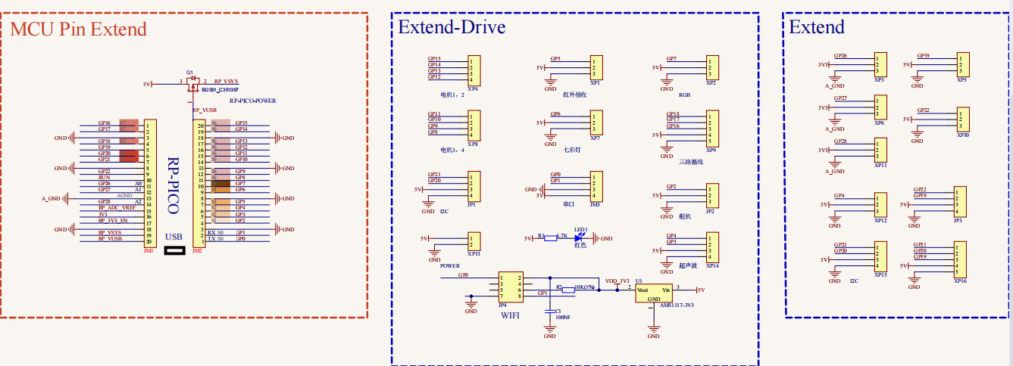

**4.Interface**

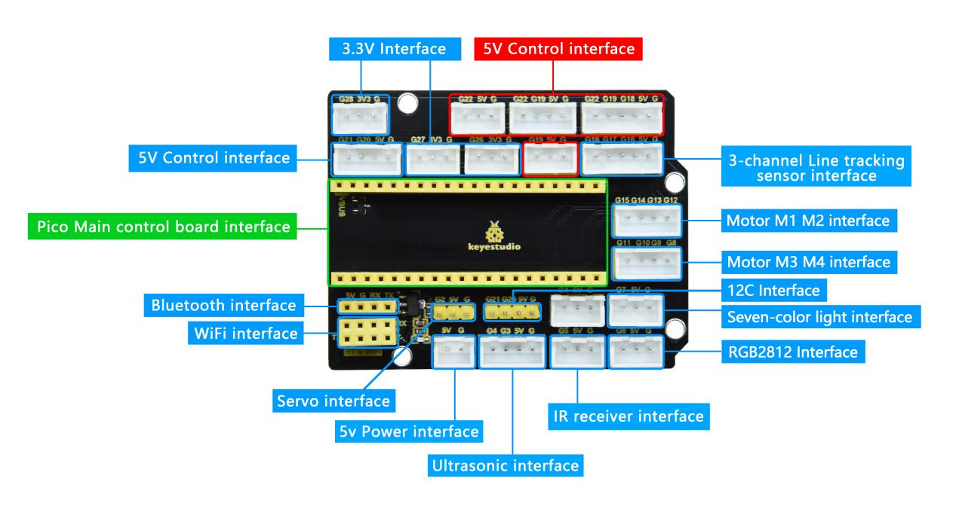

**5.Using Method**

Stack the Raspberry Pi Pico on the expansion board, as shown below:

